Unified Robotics II- CS HW2

* 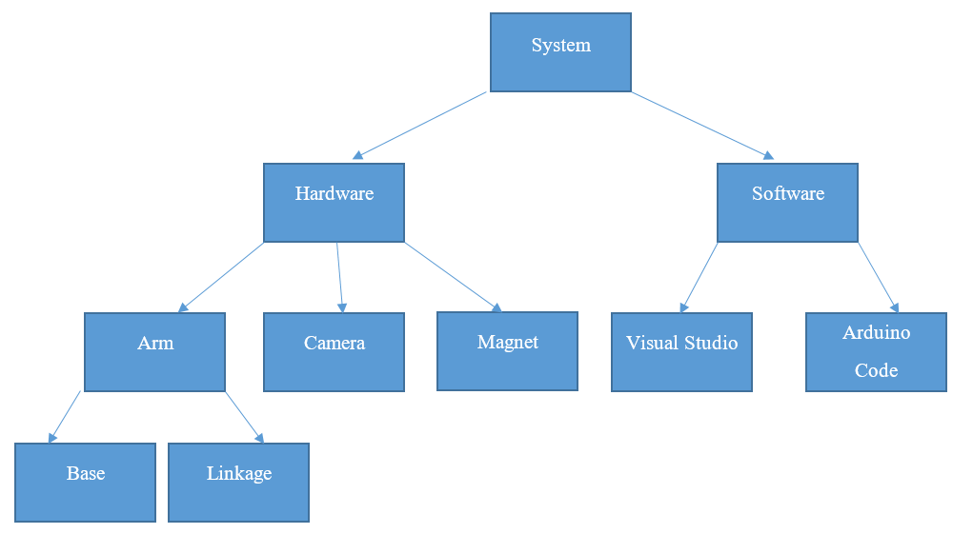Block Diagram

Arduino Control Code

C# Image Recognition

* System Design Block Table

System Name: **Pick and Place Robot******